**EXERCISE: INCIDENT REPORT**

Here’s an e-mail received from a friend:

*Hi there!*

*Well, I nearly caused a panic today because I thought I had found a mega showstopper on the trading system we are testing. The test manager and others got involved examining databases first on the server and then on the gateway that feeds the clients, checking update logs from processes that ran overnight as well as checking data passed to the client. Eventually I found the problem. I had mis-clicked on a .bat file when running up a client and had run up the wrong client environment. By that time the test manager was ready to say a few short words in my ear, particularly as the development people had started to get involved and they have zero tolerance for mistakes made by testers. The only saving grace was that I found the mistake and not one of the developers.*

*It was, objectively, an interesting mistake. When you log into the server test environments, the panels always show the environment to which you are connected. In our case we have two test environments called Systest14 and Systest15 and my tests were set up in Systest15. To run up the clients, we have to run .bat files for either a 14 or 15 client. I had started two clients, that is two exchange participants, so I could do some trading between them.*

*It appears I started the first client OK in environment 15 but when I started the second, I accidentally moved the mouse a fraction so it ran the 14 .bat file that is next to it in the Explorer file list. To make matters worse, the client screens do not show the environment to which you are attached.*

*At first I felt a bit stupid having caused much hectic and wasted activity. On reflection I thought that if I, as a reasonably competent person, can make a mistake like this then something is wrong. On the server side when I log on to a test environment, I have to enter the environment name and it's shown on all the panels. On the client side, I run a client test environment by selecting a .bat file from a list of many and have to ensure I click on the right file. There is neither a display nor the ability to determine the client environment in which I am working.*

*So I am going to log this as a high priority, or even showstopper, error - the client does not show the environment. In real life terms, it means a real user could be connected to the production system and think he is connected to a test system and screw up trading. I know this happened once on the equities trading system, when a trader entered a load of test transactions into the production system by mistake and caused mayhem.*

*As an addendum to this story, a couple of days later one of the testers found what appeared to be another mega showstopper. He and the test manager spent three hours crawling all over the system before they discovered the 'error'. A new filter had been added to the client software to filter transactions displayed in panels by geographical market. Unknown to them, it was set to a default of the German market, whereas they thought they were in the UK market. Consequently, at first sight, it appeared there were fundamental problems with the network transaction bus and the message-broadcasting systems. Apart from the issue that they should have been informed of this change, it raised a similar problem to the one I had experienced -the client system does not display the market in which you are trading.*

*Well - I'm off for another happy day at the office! All the best*

Use the incident template to transform that e-mail into a well-written defect report. Make sure you take into account and resolve some of the problems with the e-mail. Feel free to use your imagination to create additional details you might need for a good defect report.

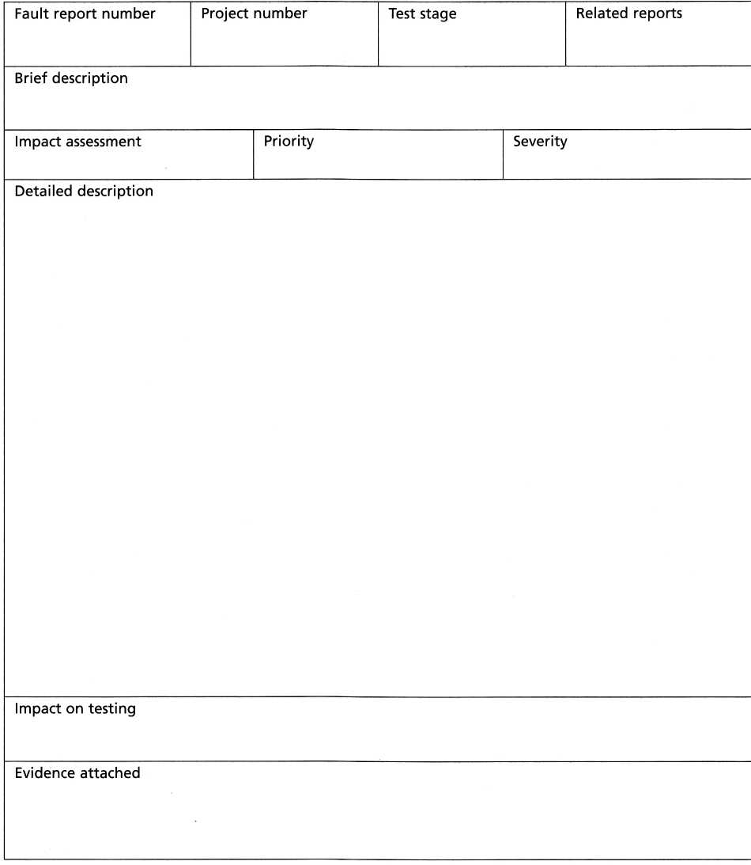

|  |  |  |  |  |
| --- | --- | --- | --- | --- |
| **Fault report number** | **Project number** | | **Test stage** | **Related reports** |
| **Brief description** | | | | |
| **Impact assessment** | | **Priority** | | **Severity** |
| **Detailed description** | | | | |
| **Impact on testing** | | | | |
| **Evidence attached** | | | | |